Supplementary Material
Preprocessing Techniques -
1.Handling Missing Values -
a. Framingham Dataset -
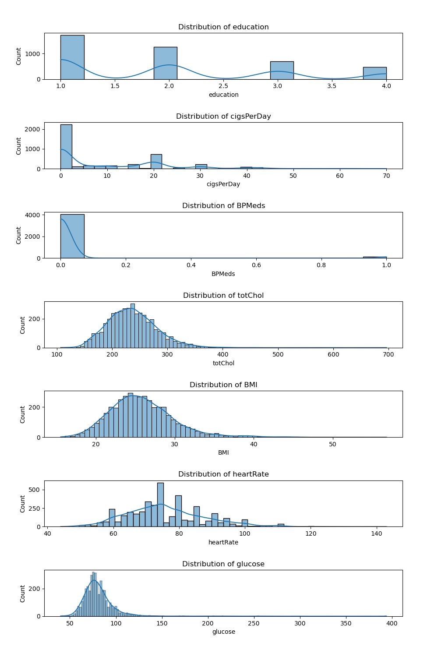

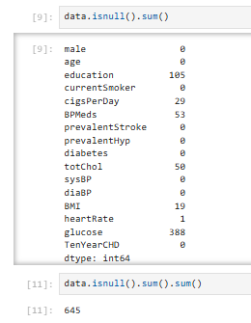 | 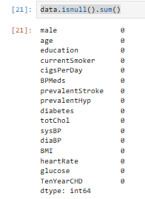
Missing Values in Framingham Dataset (before and after handling)

b. Indian Dataset - No missing values were found in the Indian dataset.
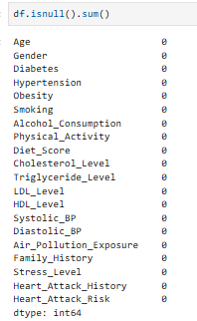

2. Data Balancing: -
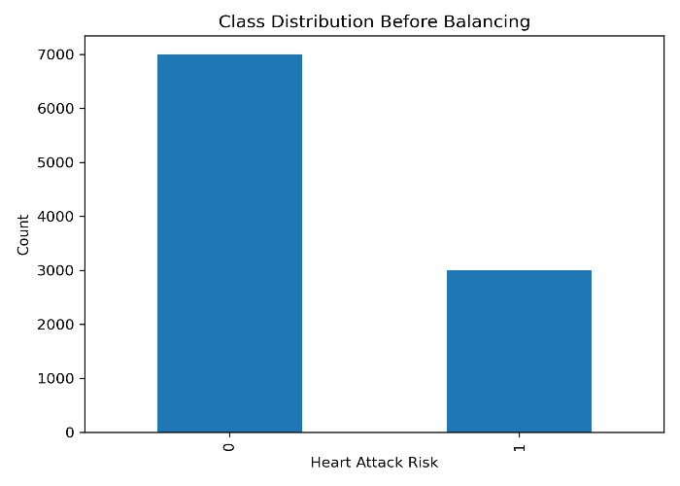 | 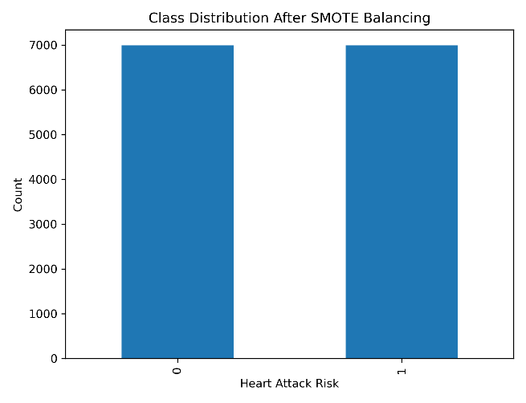
Data Balancing_Indian Dataset
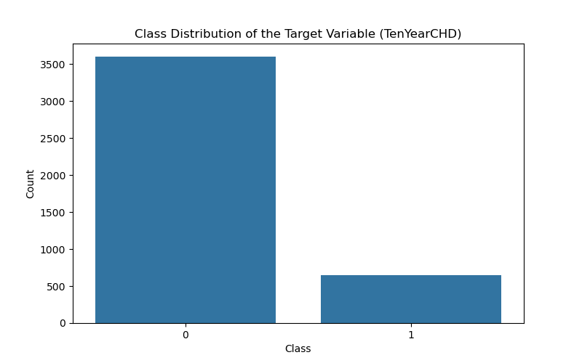 | 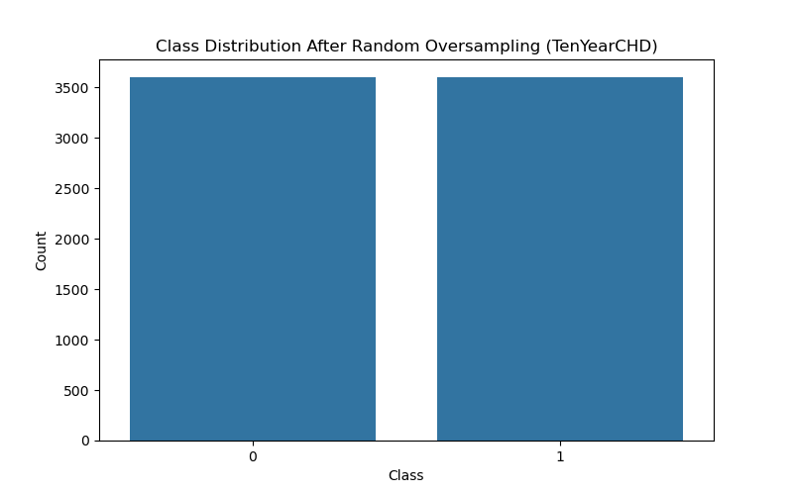

Data Balancing_Framingham Dataset

3.Outlier Handling –
No Outliers were found in the Indian dataset.
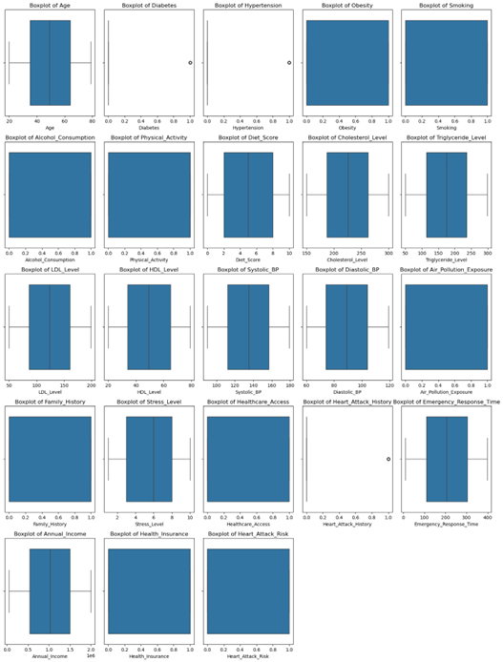
Boxplot of Indian Dataset
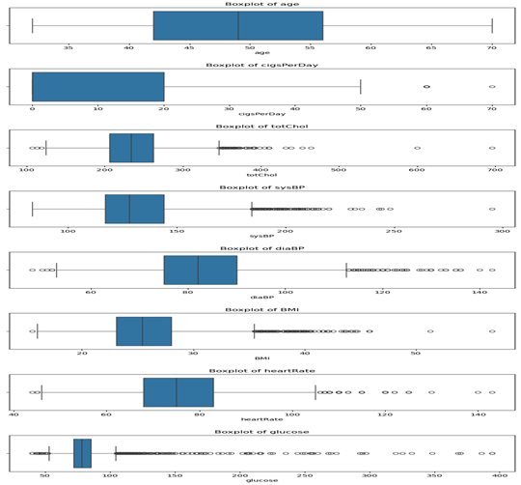 | 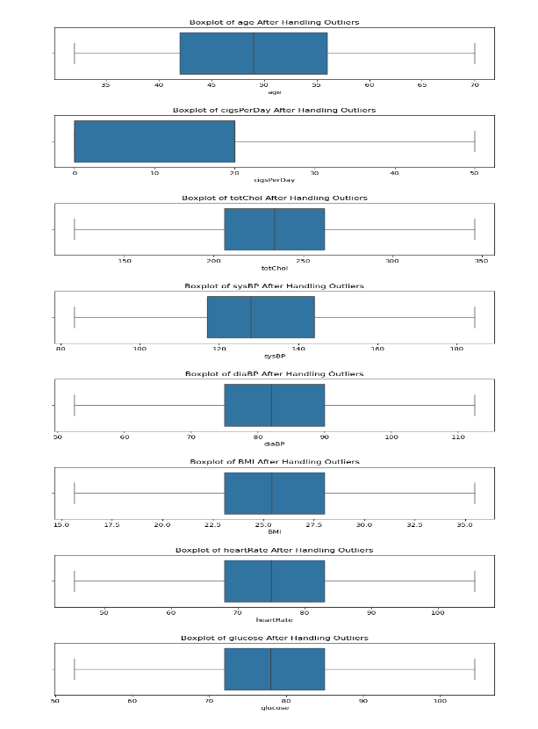
Boxplot of framingham Dataset before and after handling outliers
4. Feature Importance with ReliefF:-
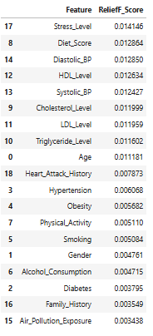ReliefF Importance Score_Indian_dataset | 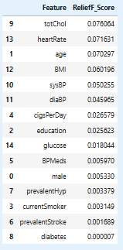  ReliefF Importance Score_Framingham Dataset

